A Colorado Program Supporting
Local Restoration Projects

Background

Since the establishment of the Colorado Healthy Rivers Fund in 2003, over 125,000 citizens have donated nearly $1,100,000 to fund more than 80 local water enhancement projects in Colorado, spanning the seven major river basins.

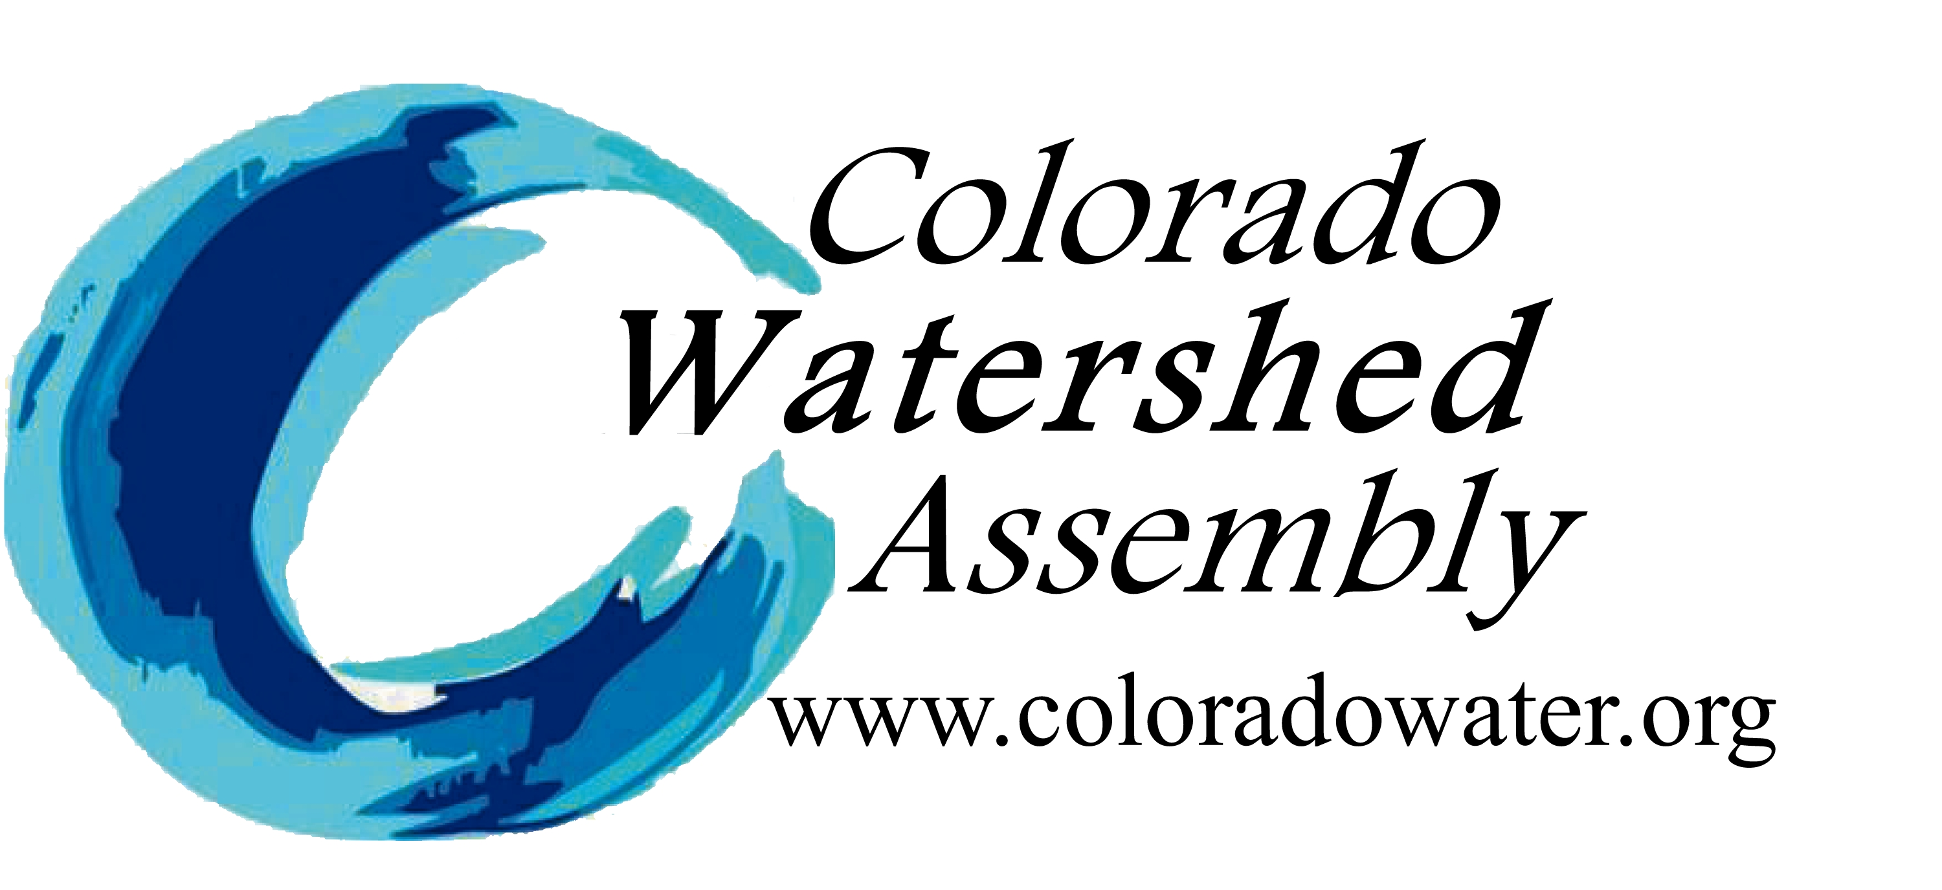
The Fund grants money to on-the-ground projects that contribute to cleaner water, healthier wildlife habitat, and improved recreation throughout our State and is administered through Colorado Water Conservation Board in association with the Water Quality Control Division and the Colorado Watershed Assembly.

Facts
LINKS
cOLORADO wATERSHED aSSEMBLY http://www.coloradowater.org/hrf/

cOLORADO WATER CONSERVATION BOARD
http://cwcb.state.co.us/LoansGrants/colorado-healthy-rivers-fund-grants/Pages/main.aspx
- Local watershed groups use CHRF grants to leverage larger sums of money from private and government sources.
- The program is included in Tax Check-off Colorado, a voluntary contribution program for State Taxpayers.

- Projects funded by the Colorado Healthy Rivers Fund are matched with an average of $6 for every $1 donated.

- Applications to receive funding from CHRF are due April 30 of each year.

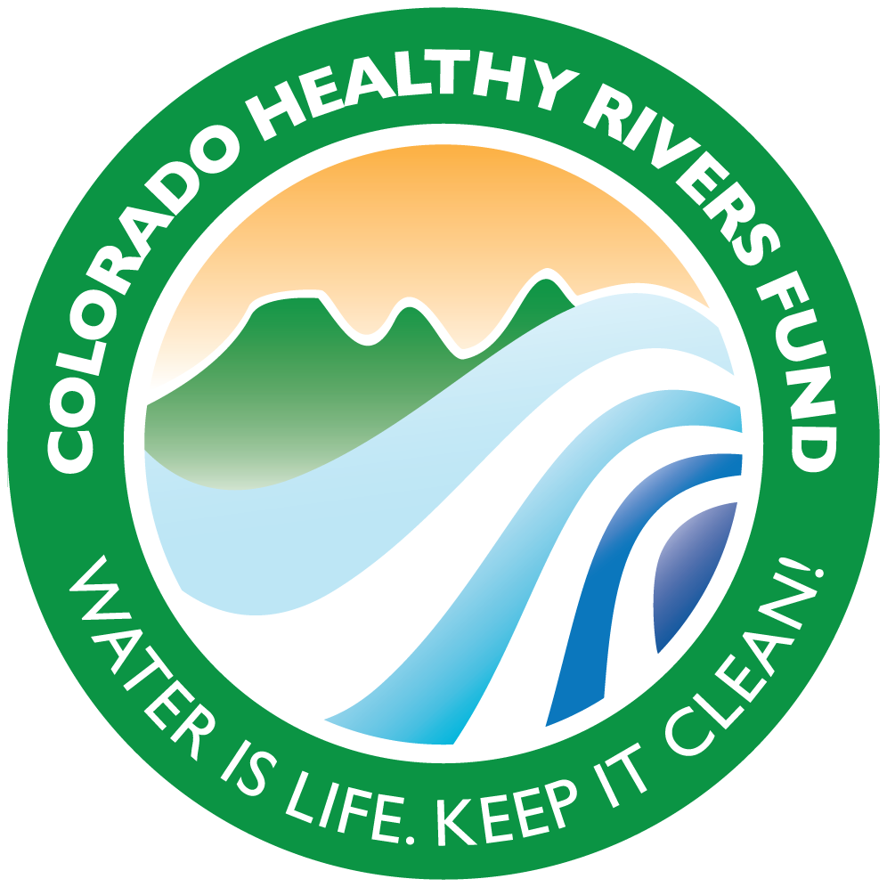

Project Profile

Groundwork Denver (GWD)
River Restoration & Riparian Re-vegetation 2015
(Healthy Rivers Fund $15,000)

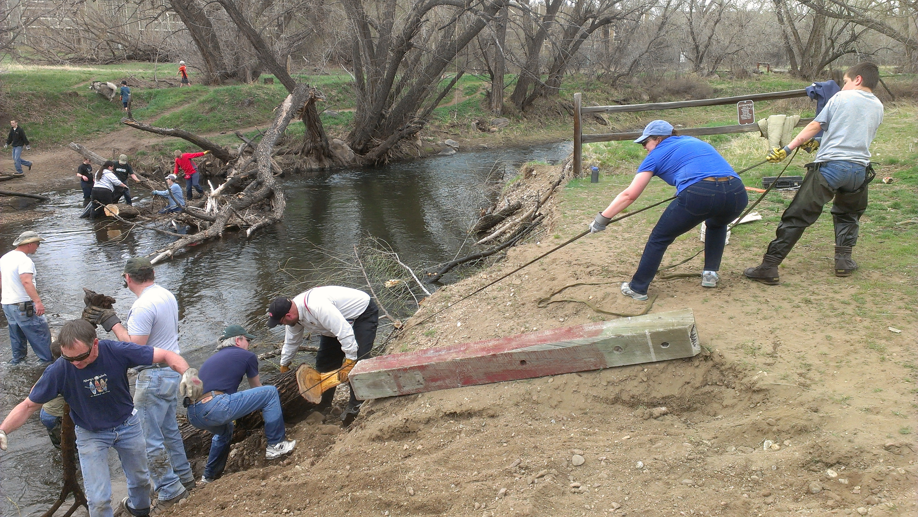
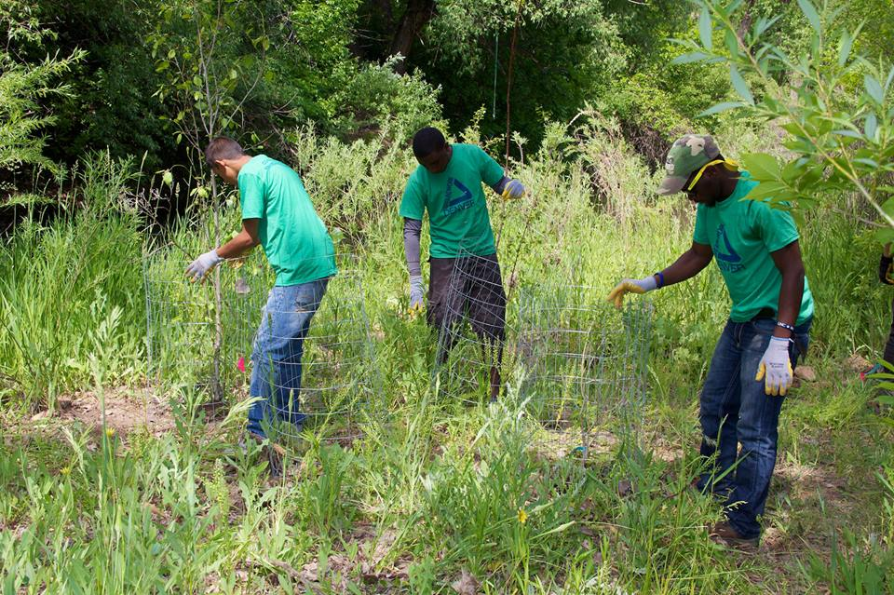
Groundwork Denver Youth Green Teams and volunteers removed invasive Russian Olive trees over a two-mile stretch (approximately 40 acres) in the Denver section of Bear Creek and took inventory of Purple Loosestrife in the Bear Creek Natural Area as part of invasive management control. In addition, GWD applied a sand/paint mixture to protect native trees from beavers, removed an estimated 2,000 pounds of trash from riparian areas, and collected data on the size and health of 219 native cottonwood trees.
Photos Courtesy Groundwork Denver

Photos Courtesy Groundwork Denver

Map

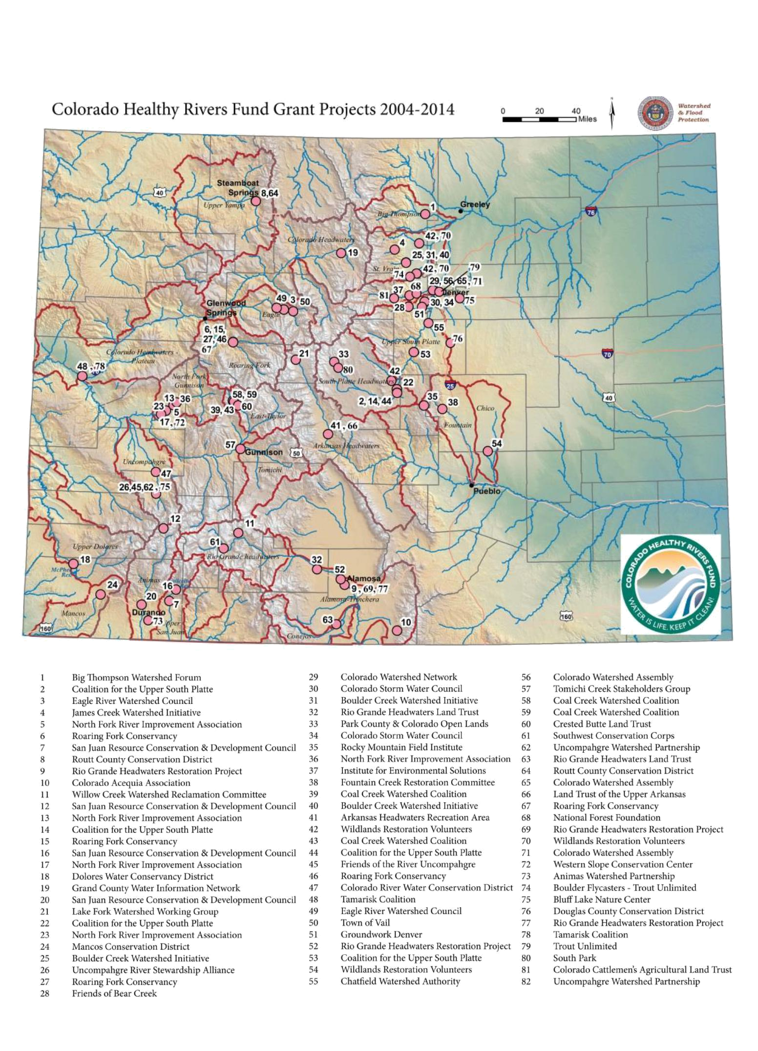
The map below shows the locations where the Colorado Healthy Rivers Fund has awarded grants to local conservation groups. For more information on the funds provided and the types of projects funded, please visit the CWA website at https://static1.squarespace.com/static/53f664ede4b032c1fade347d/t/55f891d8e4b0c80742d3bea7/1442353624510/chrf_projects_2015.pdf.

